Physics Extend Essay
Davide Veardo
Deledda International School
Supervisor: Chiara Colucci (Physics teacher)
Abstract Word count:
Word count essay and abstract:
How is Air Flow Relevant on the Performance of a Car?

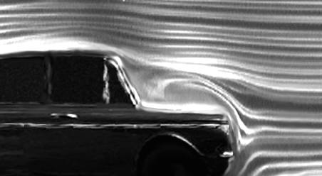
Figure 1 Land Rover Turbulence

Abstract

Contents
Title Page……………………………………………………………………………………………………………………………………………………………1
Abstract……………………………………………………………………………………………………………………………………………………………..2
Contents…………………………………………………………………………………………………………………………………………………………….3
Introduction……………………………………………………………………………………………………………………………………………………….4
Background Physics
- Fluid flow………………………………………………………………………………………………………………………………………………5
- Dropping pressure………………………………………………………………………………………………………………………………..5
- Ground effect……………………………………………………………………………………………………………………………………….5
- Efficiency of boats, cars and planes………………………………………………………………………………………………………5
- Lamina flow vs. Turbulence………………………………………………………………………………………………………………….6
- The Vortex……………………………………………………………………………………………………………………………………………7
Main Body
- Description of the experiment set-up………………………………………………………………………………………………….8
- Variables………………………………………………………………………………………………………………………………………………9
- Method and calibration………………………………………………………………………………………………………………………10
- Some thoughts about the pendulum………………………………………………………………………………………………….10
- Hypothesis………………………………………………………………………………………………………………………………………….11
- Collecting data and Processing Data…………………………………………………..………………………………………………14
- Errors and Uncertainties…………………………………………………………………………………………………………………….24
- Interpretation…………………………………………………………………………………………………………………………………….25
- Further thoughts………………………………………………………………………………………………………………………………..26
Conclusion
Bibliography
Appendices

Introduction
My first idea for this extended essay was to research on the air flow and aerodynamics of Formula One cars. Even if the idea was great, the difficulty of modelling air passing over any sort of car stopped me. It is for this reason that I decided to investigate on something linked with air flow, but which was easier to put in practice and which was also much more linked with air flow on everyday life cars.
If we take as examples a Ferrari and a British Land Rover Defender, we can immediately observes two opposite concepts of aerodynamics applied to cars. The Land Rover is basically an iron box designed for extreme adventures which gives the possibility of having a lot of space. The image in the title page show the Defender hitting air creating turbulence and braking effect.
Instead, Ferrari had been always designed in order to minimise drag and maximise power efficiency. The image below shows that there is a minimal disturbance of air and that vortices are not present.
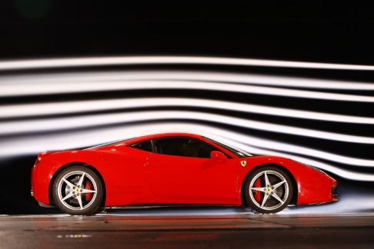
Figure 2 Ferrari Turbulence
It is for this that I decided to investigate on vortices. A vortex is a spinning and spiralling state of fluids which has energy. Therefore, it is reducing energy from the vehicle. This has several consequences: reduction of acceleration, reduction of top speeds and reduction of fuel efficiency.
In order to have something which was visible, analysable and recordable, I decided to use smoke for my experiment. Thanks to the Internet I found out some good models which could fit into my apparatus. The main idea was to use a smoke gun. I saw a ‘Air Bluster Toy’ which made smoke rings. I was unhappy about buying it because it was a toy, something I did not constructed and moreover something I could not control entirely. I had to control the intensity of the initial push. At that point I decided to buy material in order to construct myself a smoke gun. This was perfect because I could also control the intensity of the initial push by putting a rubber membrane to one of the two ends in my cylinder. This membrane was then hit by a pendulum. At the other end I stuck a piece of paper with a precise hole cut out of it. This was precise because I spent lots of time to find the best size.
After I finished constructing the gun, smoke rings had been created and I investigated on the relationship between their speed and the angle of the pendulum. Thanks to my videos I found speed from 4ms⁻¹ to 10ms⁻¹. I expected the smoke rings to be much slower. Another surprising aspect was the presence of a second and slower smoke ring. My gun is a turbulence creator, something that cars are trying to avoid. Because of my gun I was able to start investigating air flow and its relevance to the performance of cars in general.

Fluid Flow Theories
Any type of fluid is a medium. Obviously fluids have characteristics that no other mediums have. Fluids has no fixed shape, fill a container without gaps and cannot transmit shear forces. Shear forces are those forces which are applied to an object and then transmitted to a another one, making it accelerating together with the first one.
The diagram below shows a glass tube with a thin neck. It has three vertical open tubes, A, B and C. This apparatus can be seen in many schools. When water flows along the pipe the water height drops in B. Why?
If we take into consideration the image above we must say that water is entering from the left end and exiting from the right one. Pressure in this canal is lowest at B and highest at A and C. It is surprising, but also obvious, that speed is fastest at B and slowest at A and C. From what had been written it is clear that there is an inverse proportionality between pressure and speed. This is happening because water must maintain its original flow. In order to do that water must speed up from A to B.
Higher the speed in fluid lower the pressure
This is a key idea that we will visit many times: the faster the air moves, the lower its pressure, as shown by a twister.
If we then take as an example two pieces of paper and we blow between them we will see that they stick together. This is surprising, but it clearly shows the drop in pressure with speed. This is vital also in Formula one where it is called ground effect. The ground effect could be explained by dropping a piece of paper on a smooth desk, it sometimes glides for several metres. It seems to ‘flow’ on highly fluidised layer of air. Well-designed fast cars are trying to create this effects. They must creating ground effect in order to decrease friction, but they also have to maintain the car attached to the floor. The diagram below clearly shows what is happening in Formula One cars.
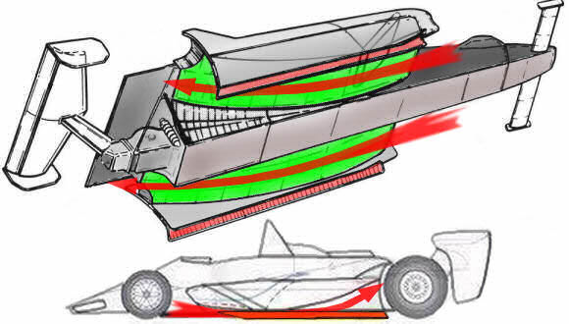
Figure 3 Ground Effect F1

Lamina vs. Turbulent flow
Light a match, let it burn a little to warm up then blow it out and hold it steadily and observe the smoke.
The diagram below shows that in matches the first part of the smoke is smooth so lamina flow, but the second part of it has spirals so turbulent flow.
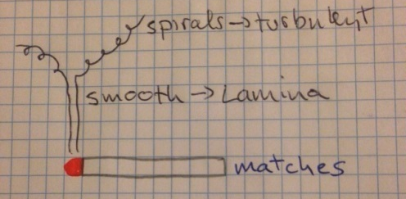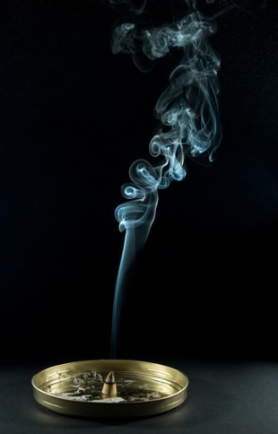
Figure 4 Lamina and Turbulent Flow
In cars, boats, aircraft and birds successful design creates Lamina flow. Turbulent is extra movement which means more Kinetic Energy. Turbulence, as a consequence, ‘steals’ energy from the moving body. This brings to the concept of lift in wings, boats, birds and downward push in Formula Ones.
A good wing has a smooth, slightly broad entry, a gentle curve, long ‘tail’ and a very smooth finish. Thanks to Newton’s third Law we are able to explain what is happening in wings. The air passing above and below the wings, if in Lamina condition, is creating a downward force and as a consequence there must be an equal and opposite force which is lifting the wing up. Formula One designers wants to create the same situation upside-down. they want a lift directed to the pavement, in order to maintain their car in contact with the road.
For both wings and F1 the inclination is fundamental, not to create turbulent flow.
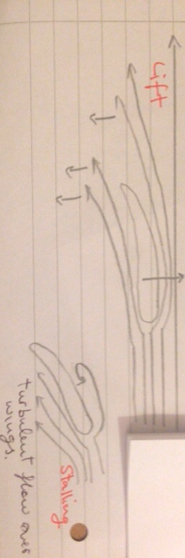
It’s worthy to remember that efficiency is playing an important role for these procedures.
$Efficiency = \frac{useful power out}{total power in}$ (in percentage)
Any car cannot be 100% efficient because all engine, in order to produce power, waste heat. To keep in touch with the ground all tyres require friction. Most importantly air must be moved if we want to move an object because air is always around us.
The ‘perfect’ car will create the minimum air disturbance plus some downward push.

The Vortex
We see a vortex whenever we empty a sink of water. Water spins forming a cone which can spiral. It does not matter whether it is spinning clock wise or anti-clock wise because it depends on which hemisphere you are in.
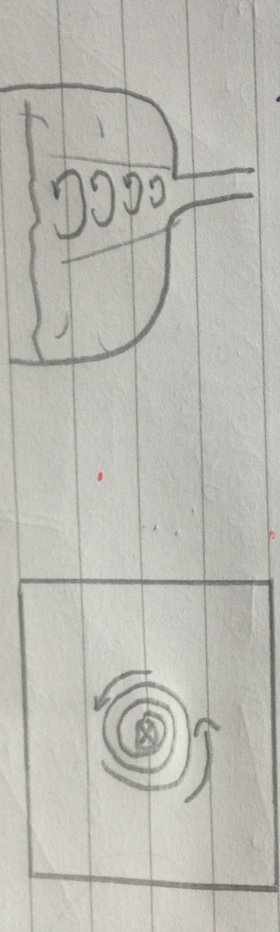
Speed seems to increase as radius of cone decreases.
A more dramatic example is a ‘twister’. It is complex and we have to be careful not to over-simplify it.
The centre of it spins fast sucking air and debris in and up. The centre of a twister is a region of very low pressure for this region it is also a region with a very high speed.
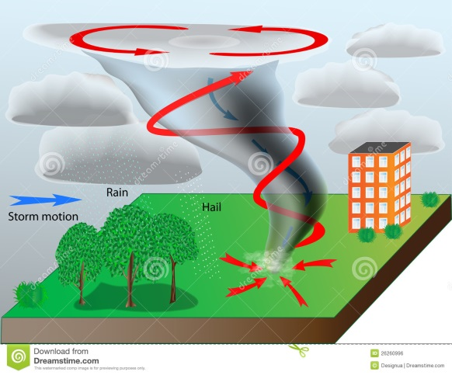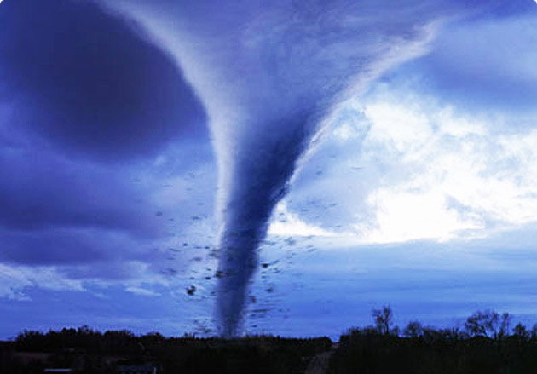
Figure 5 Tornado Drawing Figure 6 Real Tornado
It is common to see smokers blowing rings. The ring of smoke is a vortex. It spins as it moves like a twister, but it is a ring. (think of a mini-twister curved around to join end-to-end, that is a ring.) This is called a toroidal vortex.
‘Toroid ring form’
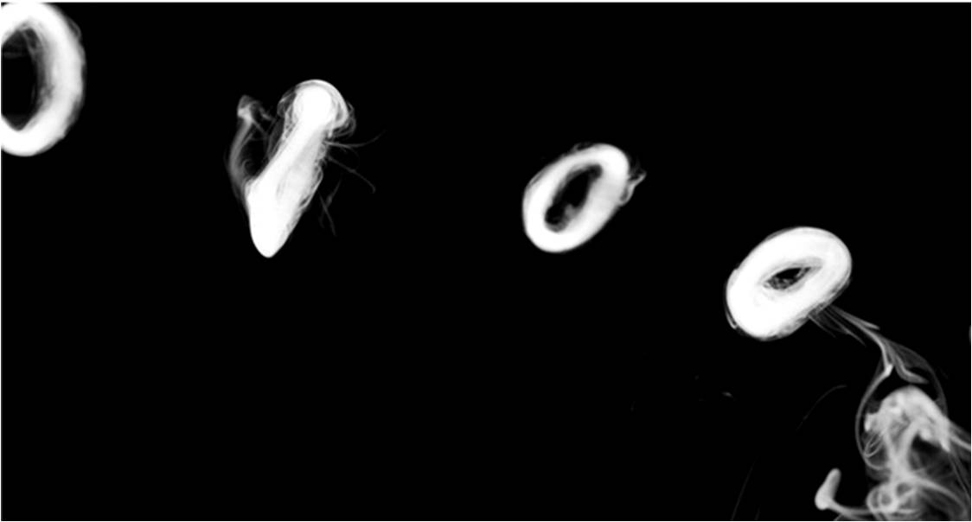
Figure 5 Smoke Rings
I will return to these ideas when I will explain what I saw experimentally.

Description of the experimental set-up
My experimental set-up started seeing a video on ‘you tube’ called ‘Giant Smoke Rings – Cool Science Experiment’. They were shooting smoke rings from a plastic box which had, at one of the two ends, a plastic membrane attached. I immediately started searching for a similar box, but I could not find it in any common shop. Due to the fact that similar boxes were practically impossible to find, I started looking on the internet for industrial water pipe sellers. Fortunately I found one very quickly and when I went there I discovered that they were selling tubes starting from 1m long. This was perfect. I bought five different cylinders with different diameters, but all had the same length.
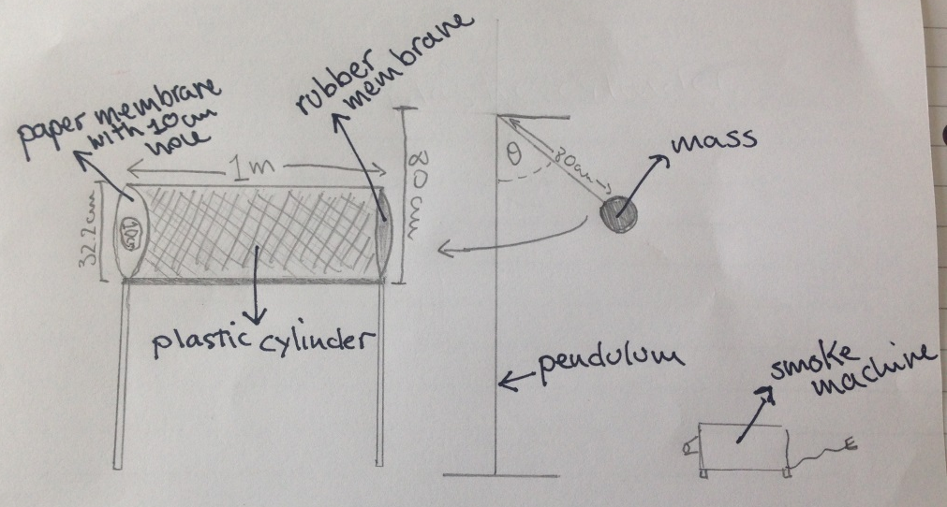
The second problem was to find an appropriate plastic membrane. This was the worst part of the entire experiment. Now, I perfectly know every plastic shop in Genoa and I know that only one of them, which is not a normal shop, sells an appropriate amount of plastics to the public. My plastic had to be both elastic, but at the same time resistant in order not to change its tension during the experiment. I bought a big rubber sheet in order to be able to cut out of it ten membranes, two for each cylinder. I bought two for each cylinder because I wanted to be sure of having a substitution if something was going wrong.
My turbulence creator was done, but I needed something which could transform into visible air movement. This was smoke. I bought a smoking machine which was transforming water into smoke. Doing that I created something analysable, visible and recordable.
I wanted my experiment to generate reliable and precise data so to control the push on the rubber membrane I have constructed a pendulum.
The last problem to solve was that keeping the exit to the same dimension of the diameter I was not able to create any toroidal vortex, I was creating only some turbulence. It is for this reason that I decided to stick a paper membrane to the second end of my cylinder and to cut out of it a precise circle which was my exit hole. I had to find the suitable size for this circle and in order to do that I performed several trials. The hole had to be 10cm of diameter.

Variables
Independent Variable: angle of pendulum to the vertical. (θ)
Dependent Variable: speed of smoke ring.
I chose these two variables because they immediately looked interesting and I was sure to have a lot of fun in analysing them during my experiment. In addition, the most important aspect of my choice was that they were both visible and measurable. It must be said that I was also sure that I was going to collect suitable data from my experiment, data I could use to write a conclusion. It should also be said that this was part of my experiment, not the beginning, not the conclusion. I was not sure about what it was going to happen, but I was hoping to get something interesting. Therefore, general observations were as important as actual data.

Method and Calibration
The pendulum had a mass of 139.7g ± 0.1g, measured with a digital mass balance.
The gun was 1m long ± 0.005m and the hole cut in the paper membrane was 10cm ± 0.2cm.
The pendulum was pulled back an angle θ ± 1º measured with a 10cm diameter protractor. The pendulum was pulled back and released many times. When it hit the rubber membrane it caused a smoke ring to flight out of the other end, which was recorded on the video. Angles of 30, 40, 50, 60, 70, 80, 90 were chosen and for each angle the experiment was repeated 7 times. by repeating these trials 7 times I wanted to find out whether my values were precise and reliable. Precise because I expected them to be in a small range and reliable because I wanted similar results each time for every angle.
The smoke ring which was shot out of the plastic cylinder was filmed with a camera. The camera was in a fixed and steady position all through the experiment, at a distance of 1.5m ± 0.1m. This is a quite large uncertainty, but it is because that we cannot really say that the smoke ring came out in a straight line. The videos collected were then cut into small ones and uploaded on ‘Tracker’. Thanks to this program I was able to analyse the path of the smoke rings along a length of 200cm ± 10cm. Again a big uncertainty due to the varying paths of the smoke rings.
The program provided me with data that I inserted in another program called ‘Logger Pro’. This program was creating a graph of distance vs. time. The gradient of the line created was cms⁻¹ so speed that then was converted into ms⁻¹.
Another table was created. On the x-axis there were the angles of the pendulum and on the y-axis there were the different speeds found thank to the other graphs.

Some thoughts about the pendulum
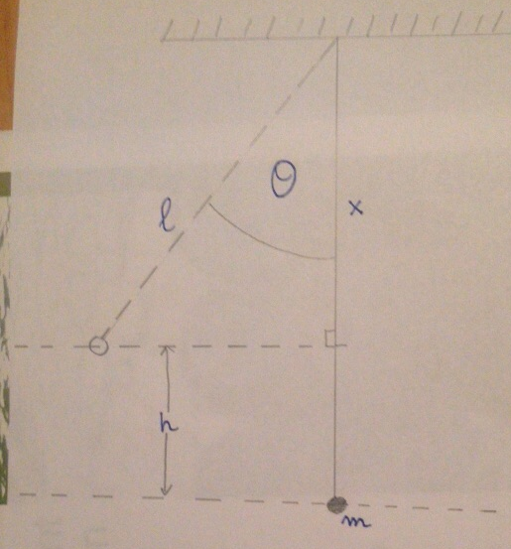
$$x=l\cos\left(θ\right)$$
$$h=l-x=l-l\cos\left(θ\right)$$
$$h=l(1-\cos\left(θ\right))$$
by the conservation of energy I can say that:
$mgh= \frac{1}{2}mv^{2}$ where $v$ is the speed of the pendulum at impact with therubber membrane.
I am now substituing h, in the previous formula with the h I found thanks to the diagram above
$mgl(1-\cos\left(θ\right))=\frac{1}{2}mv^{2}$ I do not need $m$ (mass) so I can cancel it in both formulas.
$gl(1-\cos\left(θ\right)) \frac{1}{2} v^{2}$ Now I will finda formula which will give me something similar to $v=…$
$$v=\sqrt{2gl\left(1-\cos\left(θ\right)\right)}$$
From this final formula I will be able to construct graphs between speed at impact vs. smoke rings speed, but even KE of pendulem vs. speed of smoke rings.

Hypothesis
If I pull back my pendulum, I raise it, so I give it GPE. I release the pendulum and GPE transforms into KE, which is then partially passed to the smoke. As shown below the speed of impact of the pendulum is given by:
This was derived earlier $v=\sqrt{2gl\left(1-\cos\left(θ\right)\right)}$
My first idea was that increasing θ would have increased also the speed of the smoke. As a consequence I thought that the speed of the smoke should have been directly proportional to θ. This was not so correct. I was not taking into consideration that increasing θ was inevitably increasing also $h$ ($h=l(1-\cos\left(θ\right))$. This could be fine, but I had to consider that $h$ was not raising proportionally in respect to θ.
I concluded that there were two possible hypothesis. The first one was that the speed of the smoke was equal to the impact speed of the pendulum. The second one concluded that the speed of the smoke should at least be directly proportional to the impact speed of the pendulum.
Obviously both of these two hypothesis could be wrong because I have to take into consideration also elasticity of the membrane, viscosity of air, turbulence and chaos. Chaos is the state in which performances cannot be repeated and follow no rules. Some weather patterns in chaos. The graph below shows the first and the second hypothesis. A suggests that rubber membrane could be seen as a piston moving and at the same time pushing air at the same speed. Instead, B states that the pendulum could be a mass with a certain speed which is hitting a smaller masses that after the impact would have a greater speed in respect to the impact one of the pendulum. B could be seen as a collision.
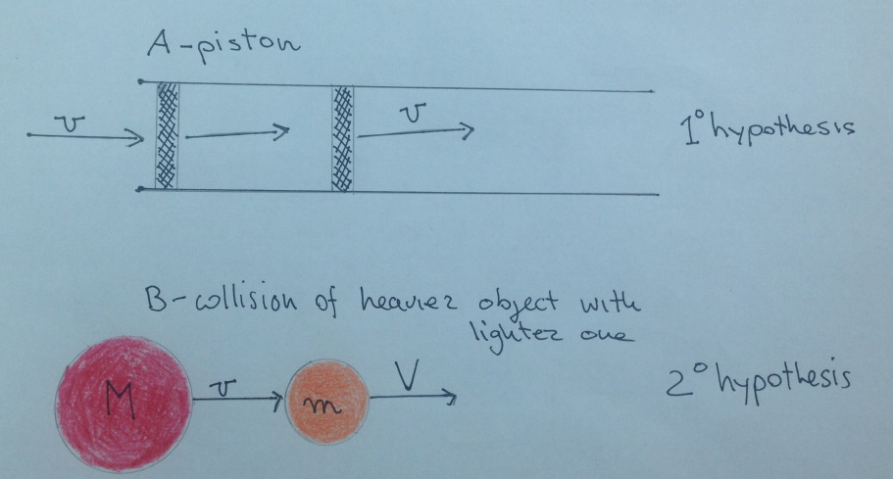

Collecting and Processing data
Graph of Distance against Time for an Angle of 30°
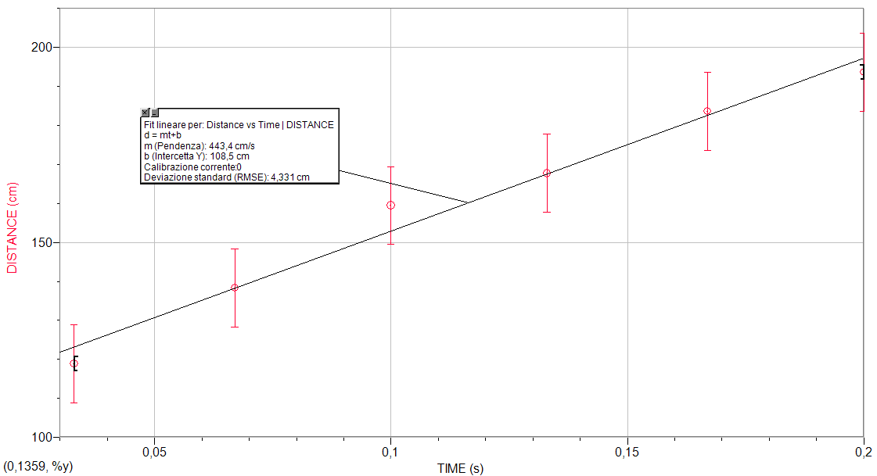
TIME (S) | DISTANCE (CM)
± 0.001 s | ± 0.01 cm
0,033 | 118,88
0,067 | 138,32
0,1 | 159,44
0,133 | 167,68
0,167 | 183,53
0,2 | 193,67

Graph of Distance against Time for an Angle of 40°
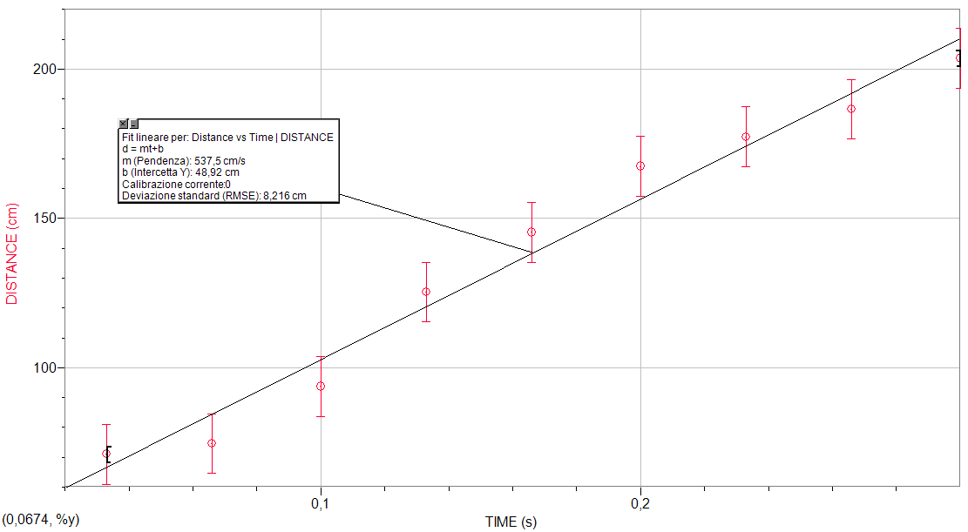
TIME (s) | DISTANCE (cm)
± 0.001 s | ± 0.01 cm
0,033 | 71,01
0,066 | 74,63
0,1 | 93,72
0,133 | 125,31
0,166 | 145,31
0,2 | 167,43
0,233 | 177,3
0,266 | 186,52
0,3 | 203,63

Graph of Distance against Time for an Angle of 50°
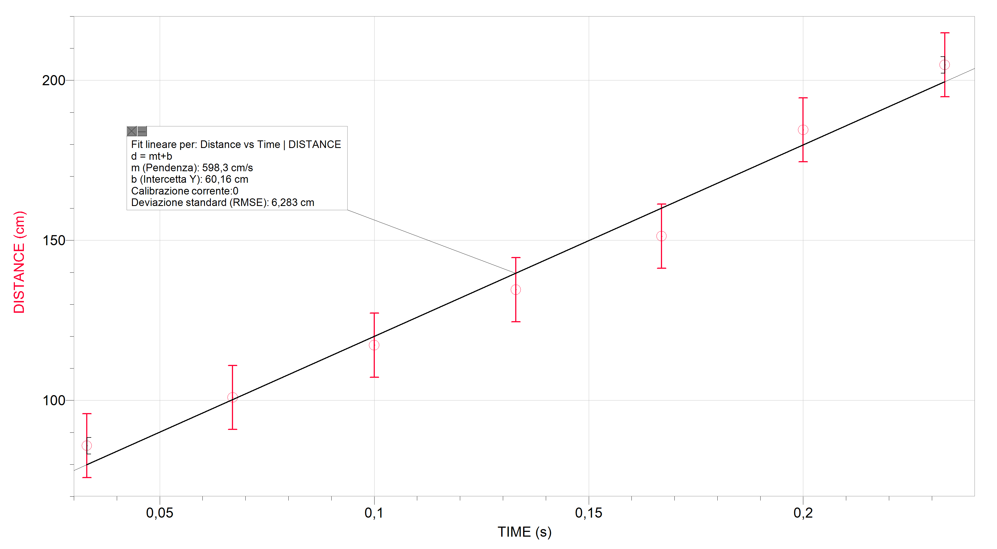
TIME (s) | DISTANCE (cm)
± 0.001 s | ± 0.01 cm
0,033 | 85,86
0,067 | 100,9
0,1 | 117,25
0,133 | 134,59
0,167 | 151,3
0,2 | 184,56
0,233 | 204,86

Graph for Distance against time for anAngle of 60°
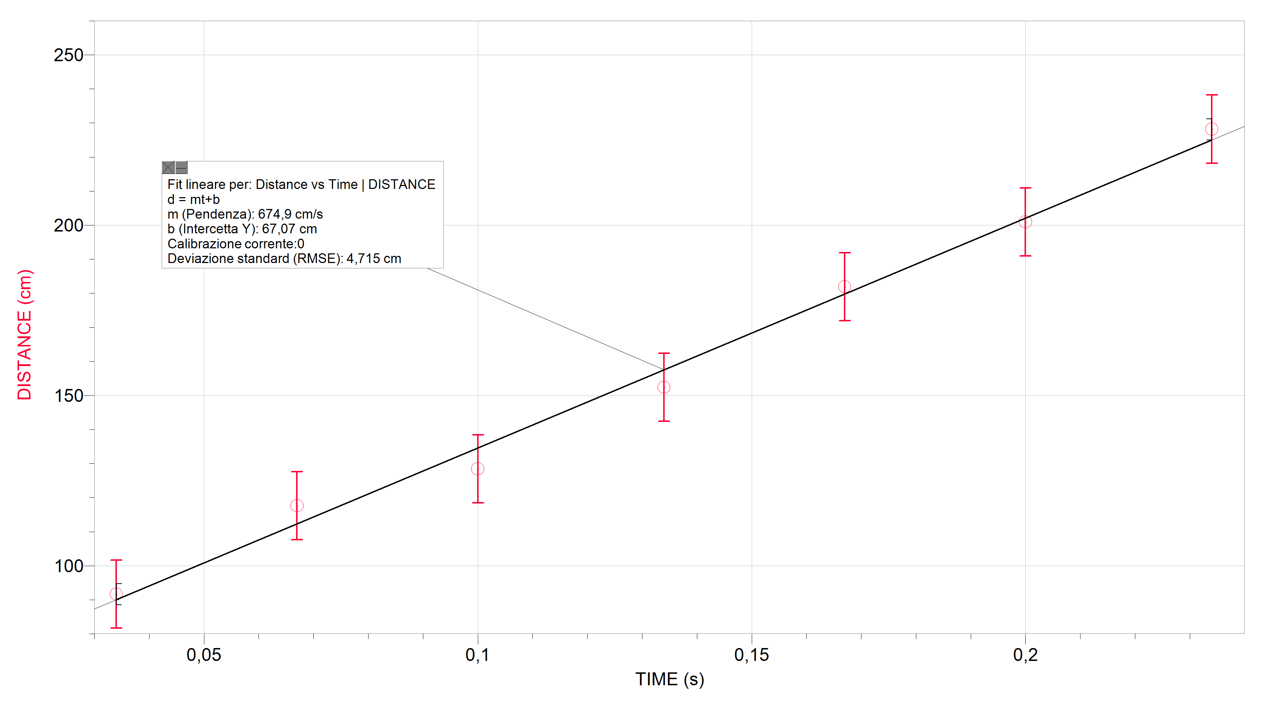
TIME (s) | DISTANCE (cm)
± 0.001 s | ± 0.01 cm
0,034 | 91,67
0,067 | 117,65
0,1 | 128,42
0,134 | 152,42
0,167 | 181,92
0,2 | 200,93
0,234 | 228,2

Graph of Distance against Time for an Angle of 70°
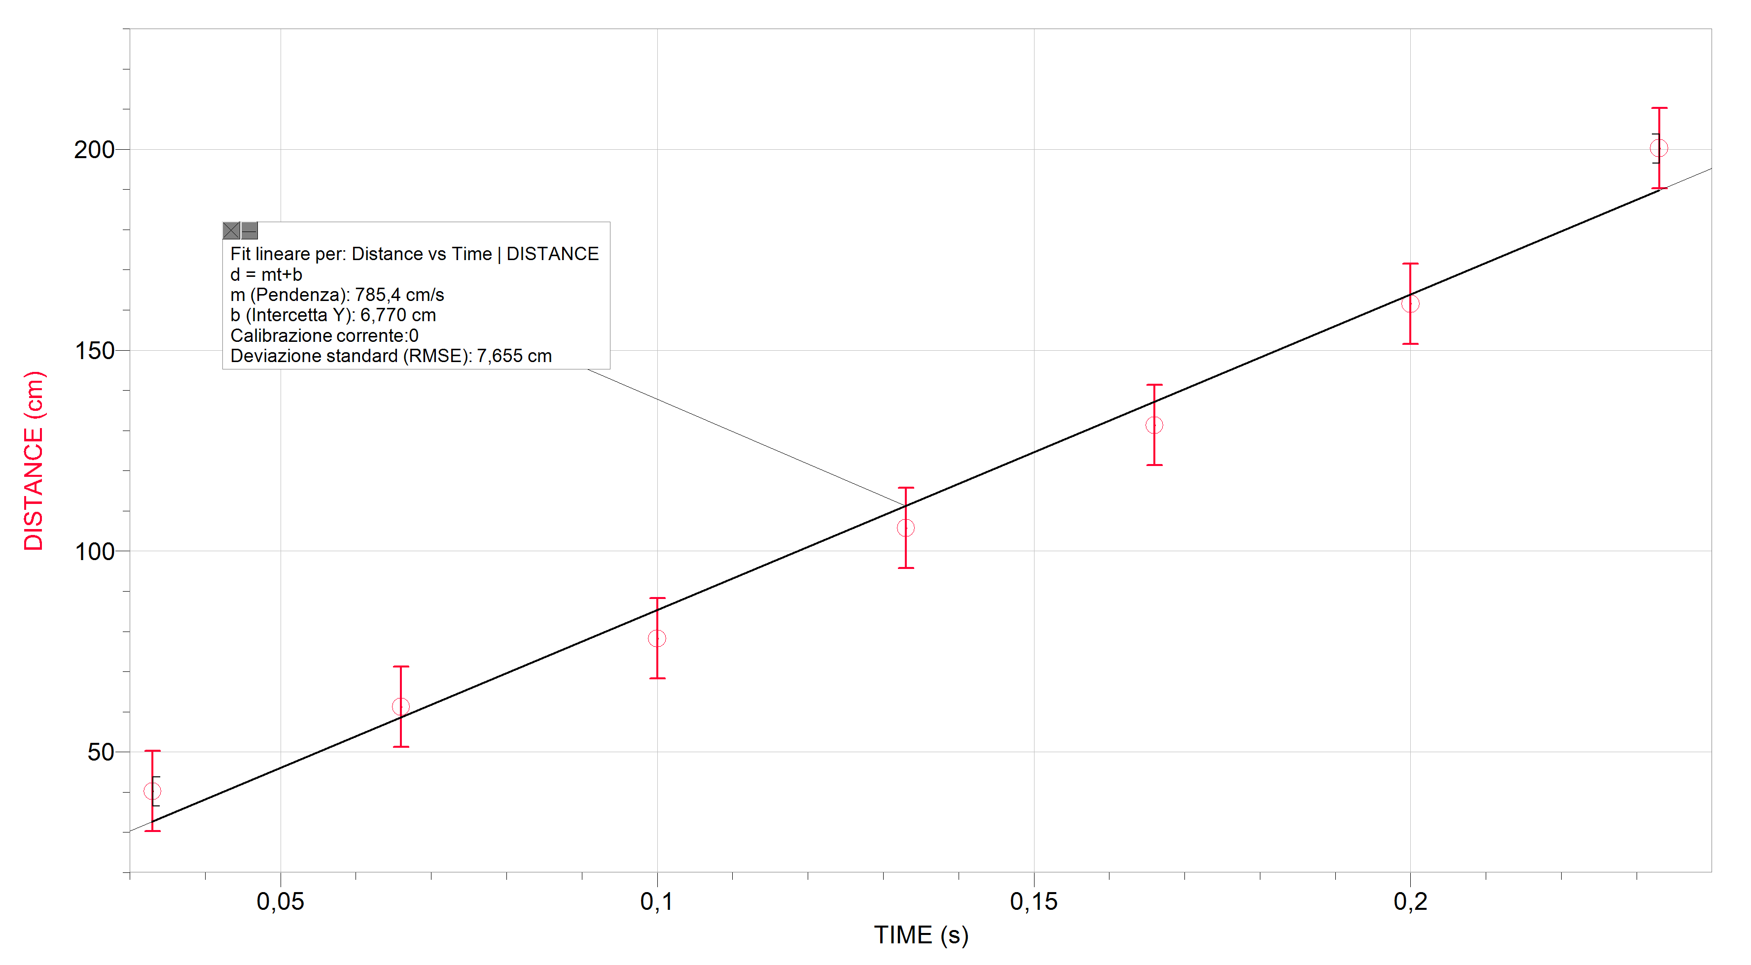
TIME (s) | DISTANCE (cm)
± 0,001 s | ± 0,01cm
0,033 | 40,25
0,066 | 61,25
0,1 | 78,27
0,133 | 105,74
0,166 | 131,33
0,2 | 161,54
0,233 | 200,25

Graph of Distance against Time for an Angle of 80°
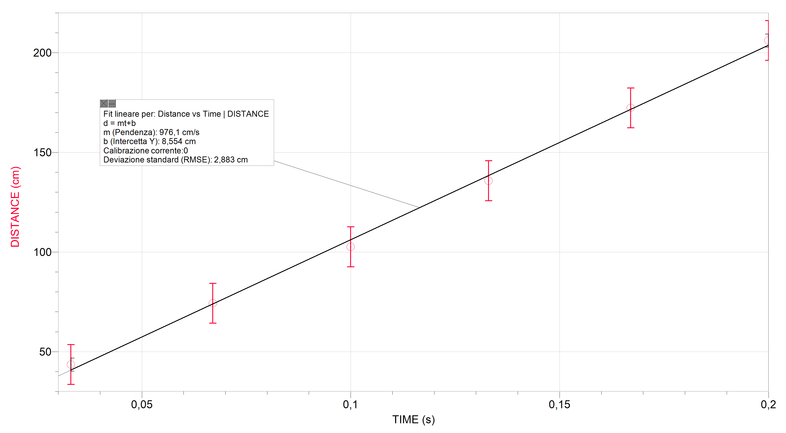
TIME (s) | DISTANCE (cm)
± 0,001 s | ± 0,01cm
0,033 | 43,54
0,067 | 74,28
0,1 | 102,60
0,133 | 135,78
0,167 | 172,31
0,2 | 206,10

Graph of Distance against Time for an Angle of 90°
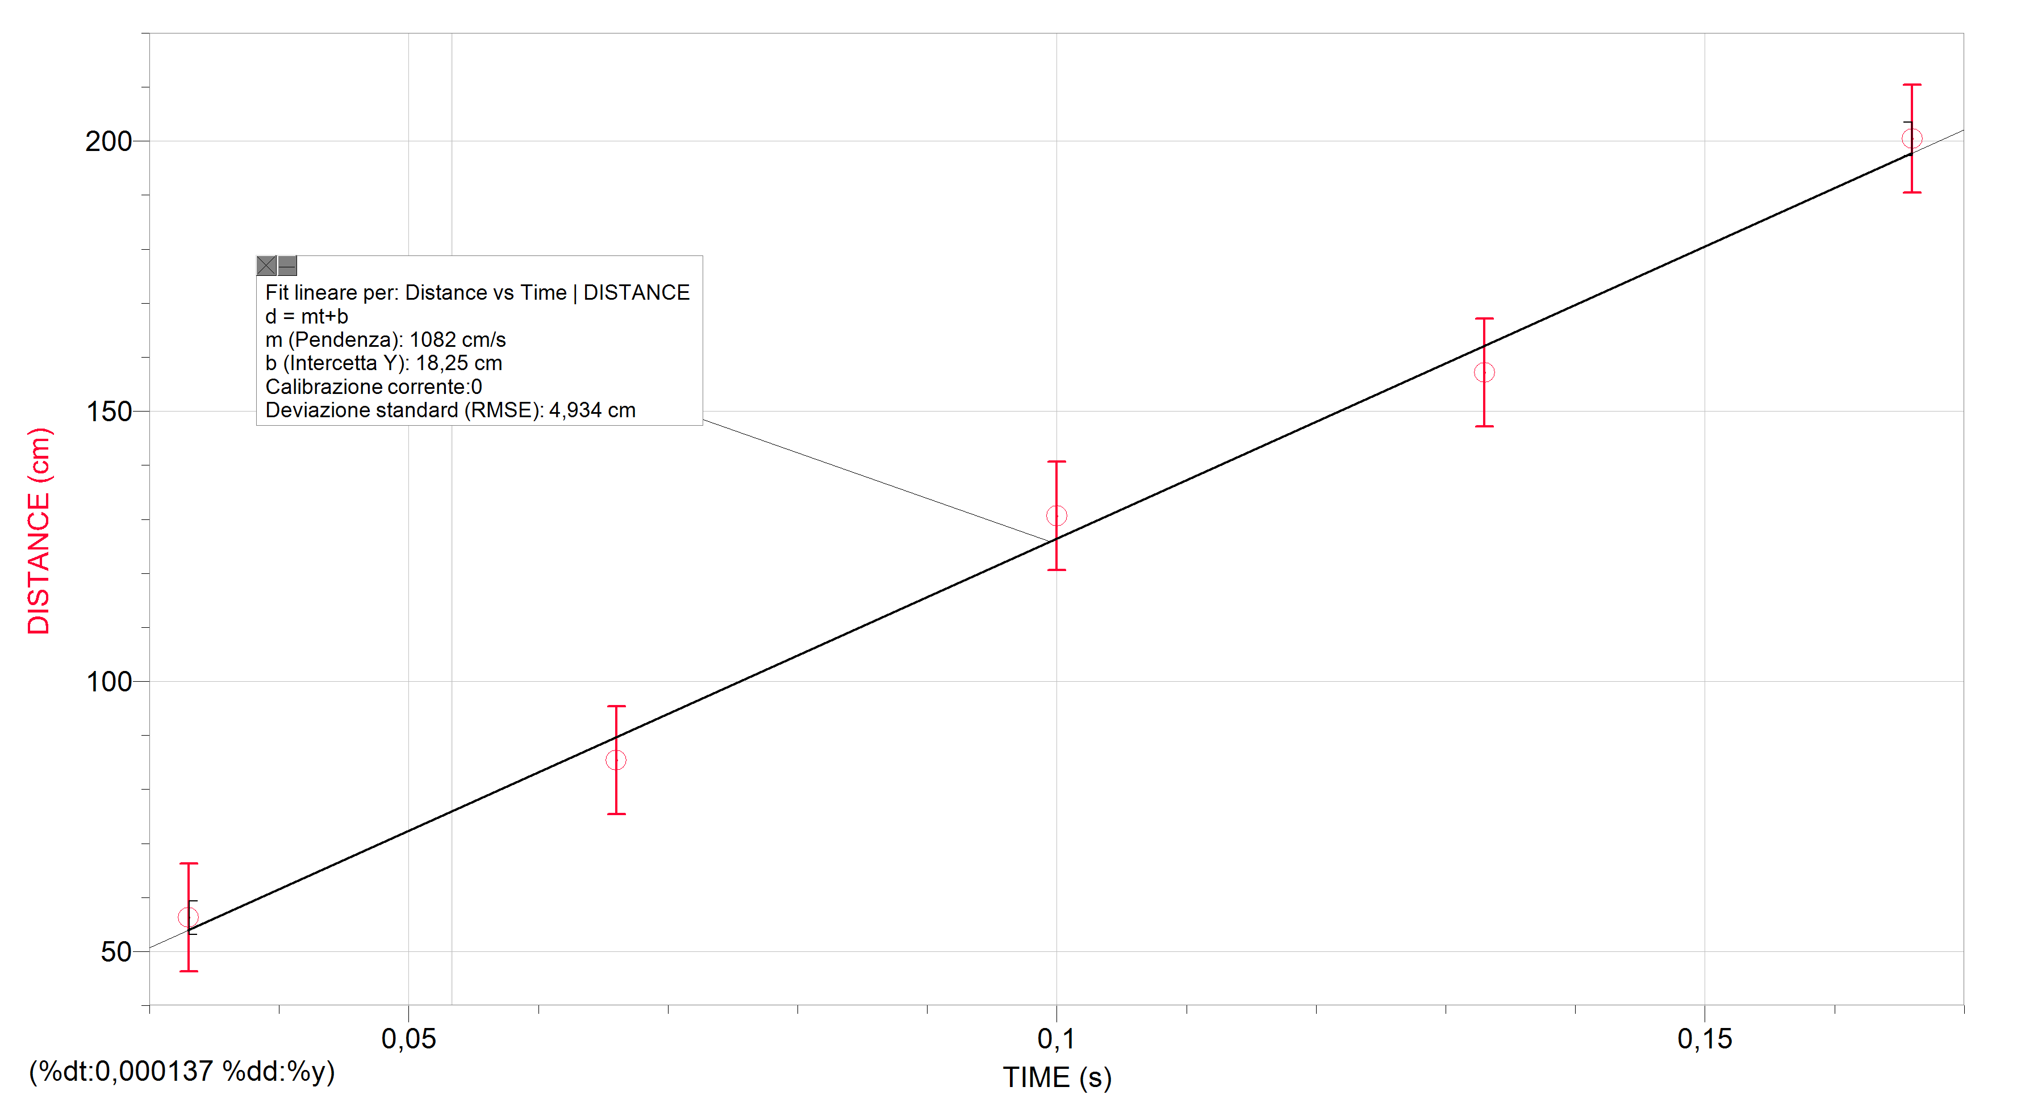
TIME (s) | DISTANCE (cm)
± 0,001 s | ± 0,01cm
0,033 | 56,27
0,066 | 85,38
0,1 | 130,63
0,133 | 157,13
0,166 | 200,44

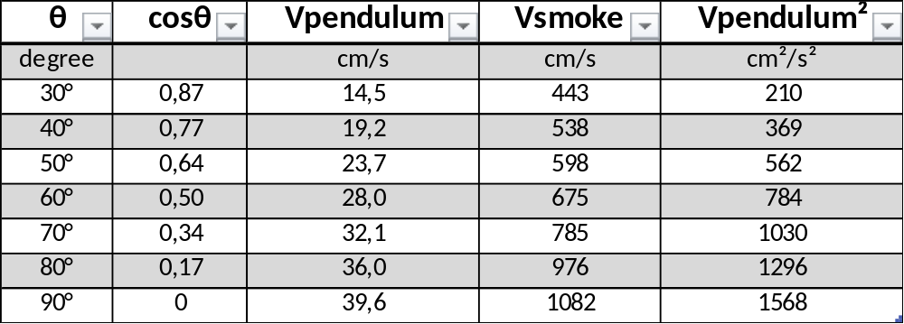

Graph of Smoke Speed against cosθ
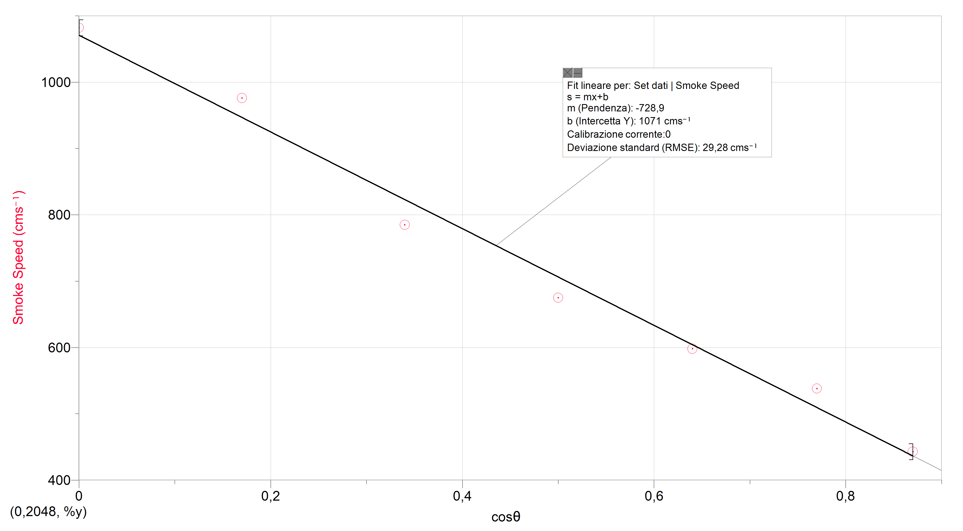

Graph of Smoke Speed against Pendulum Velocity
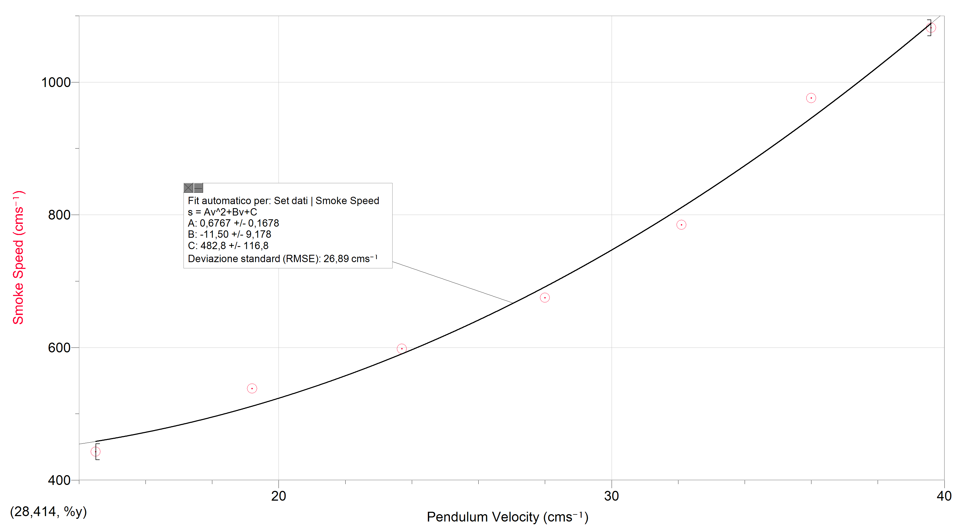

Graph of Smoke Speed against Pendulum Velocity²
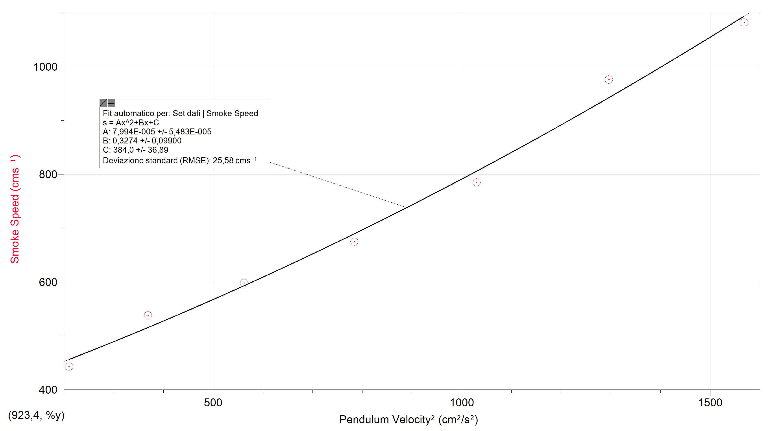

Errors and Uncertainties
I had seven trials for seven and different angles. In order to collect all these trials I recorded seven videos for each angle. Each video was then cut into seven smaller videos which were all the trials. I analyzed these smaller videos with a program called ‘Tracker’. The program was able to calculate an average of all the data for each angle. From these averages I then built up seven graphs that are shown above. The uncertainties present in the graphs are on distance and they are all the same in each graph. The error bars in all the graphs are ±10cm because I manually inserted this value on ‘Logger Pro’. They represent my estimate of the uncertainties. I took my videos with an iPhone 5 which shows 30 frames per second. Thanks to this data I able to say that there is no significant uncertainty in the times. In other words the speeds are only affected by the uncertainties on the distances. It is for this reason that I inserted error bars only for the y-axis which are distances.
The diagram below shows the Parallax error. At the point P there is the greater error because my camera is seeing the smoke ring as it was at the end of his path, 2m away from the cannon. It is not because thanks to the parallax method I am able to say that it has covered a distance of 1.83m. I calculated this applying some mathmatical theorems derivited from trygonometry, as shown in the picture. However the image shows this type of error only on the right side of the apparatus because my mark, which was indicating 2m distane, was only 30cm behind the smoke rings path. The parallax error is 0 from the cannon to the middle point and then increasing to a maximum of 17cm at the far end.
My graphs are showing a constant straight line passing through all the points and the gradient is the same for the first part and for the second one so I am not considering it as significant.
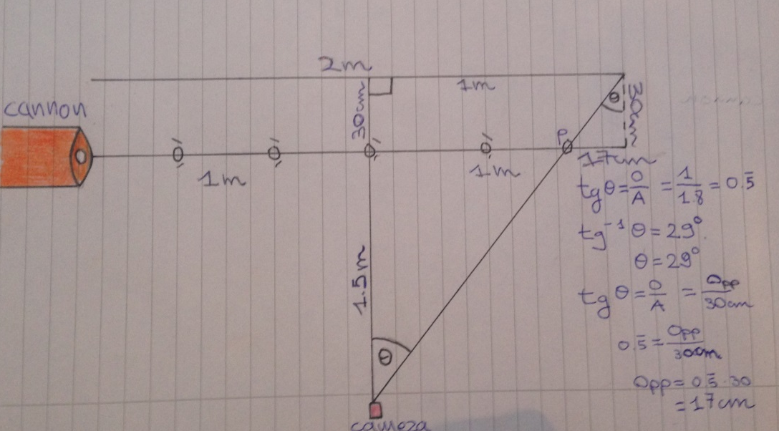
I did not filmed the pendulum movement because I did not think about it. Then I understood that it was not useful because the pendulum was accelerating and for this reason I should have analyzed only a fraction of a second before the impact. This measurement was not going to give me significant results although it would have been great to compare my predicted speeds with the actual impact ones.
Another possible source of error was the measurement of the pendulum angle which was ±2°,which I think it is acceptable.

Interpretation
From what I can observe in my graphs one can see steady straight lines showing uniform speeds for every angle, varying from 4ms⁻¹ to 10ms⁻¹. This is surprising. An interpretation could be that smoke rings move along air not being affected by air friction. As a consequence it would mean that smoke rings are obeying Newton’s First Law.
What mentioned above could lead to think that smoke rings, although exerting a force on air, are not receiving an opposite and equal force exerted by air. Are they behaving as non-Newtonian objects?
It could be said that in the path we are taking into consideration smoke rings are behaving as non-Newtonian, but we cannot confirm that, this, is also happening afterwards. Air friction could start exerting a negative force on the rings after a certain amount of time, which I am not considering. We must consider the fact that the parallax error is occurring only in the last meter and it is increasing to 17cm. This could suggest that my steady straight line, which are not considering this error, at the middle point could start curving. As a consequence this would mean that the smoke rings could start slowing down., but we cannot detect it.
If we take into consideration the graph of Speed of Smoke against Velocity of Pendulum we could confirm the second hypothesis explained above. I was hypothesizing that my apparatus was putting into action a collision. This is apparently true. To explain this I wanted to use an example a golf ball hit by a golf club.
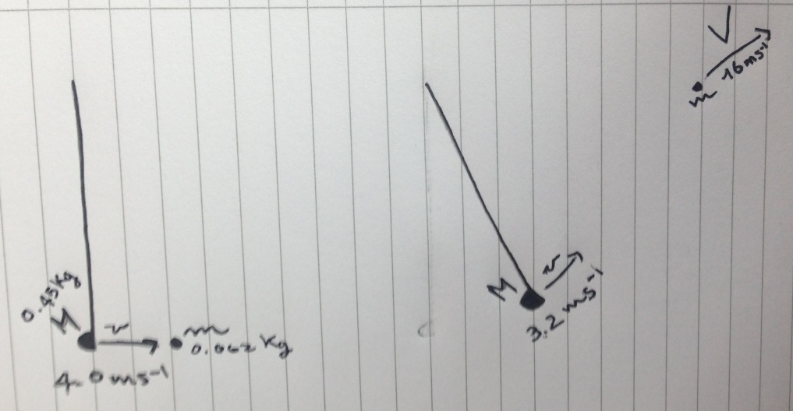
The diagram above shows the golf ball into two different condition. The one on the left shows the ball at rest, while the one on the right shows the ball moving at a certain velocity V. we can also observe that the gold club after having hit the ball slows down. So mass M, with speed v, exerts a push on mass m such that mass m acquire a velocity V. Velocity v is smaller than velocity V. This is exactly what is happening in my experiment. A heavier mass is hitting a smaller one, but the velocity that the smaller mass acquires is much greater than the velocity of the heavier mass.
From the graph we can observe a good relationship between smoke speed and pendulum velocity. We do not have to lose time in trying to model this relationship mathematically because it would be possible to create relationship in every graph, but what does matter at the end is that this relationship has to be meaningful. My graph shows a meaningful relationship, that is it.
In the first pages of my extended essay I inserted a picture representing a Land Rover Defender and one representing a Ferrari. The Defender was creating vortices, so turbulence, while the Ferrari was creating a smooth Lamina Flow. What it is happening in the Land Rover is immensely related to what is happening with my rubber membrane. For cars with very flat side in the front, such as the Land Rover, it is very difficult for the air to pass over or even creating some turbulence. Air is practically bouncing off in the flat side of these cars creating a negative force on the cars. In this case we are looking for a layer of air in front of the car and this is energetically very bad for the vehicle. The rubber membrane in my cannon is behaving exactly in the same way as this particular cars.

Further thoughts
If we observe the smoke rings and the cannon we could say that those rings can be seen as bullets, but why are the smoke rings so stable? The question can be answered using some concepts derived from rifle bullet stability. (http://www.bergerbullets.com/the-state-of-the-art-in-rifle-bullet-stability/)
In order to maintain a straight path bullets must spin and in order to do that the barrel has spirals grooves cut in it. This spinning motion reduces drag and as a consequence they can be more stable. In order to reduce drag bullets have to spin at a certain velocity. The picture below shows what is going on. This is what is happening to the smoke rings. Smoke rings are spinning objects.
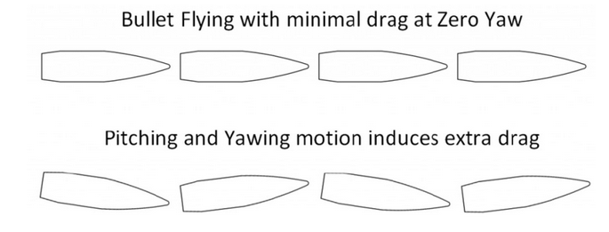
Figure 6 Berger Bullets
It could be said smoke rings are not affected by drag because they are spinning with a velocity that gives them stability and makes them fluidized, as shown below.
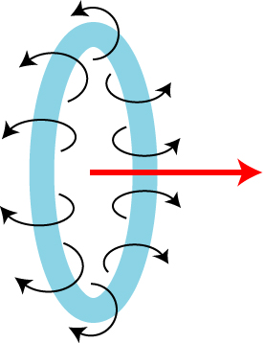
Figure 7 Smoke rings spinning
Another aspect to consider is that immediately after the smoke ring, in almost each trial, a second ring was shot although the pendulum did not exerted a second push on the rubber membrane. As the diagram below shows the second ring is not following a straight path is much slower and it is going upwards.
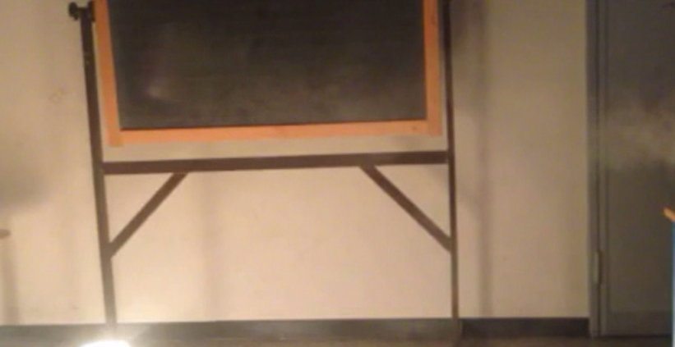
Straight Path
Second smoke rings
It could be hypothesized that the second rings is present because the air moved by the collision between pendulum and the rubber membrane once produced the first ring bounced on the paper membrane and back to the rubber membrane where it bounced again exerting a new push on the smoke creating a second smoke rings much more slower. When air bounced inside the cannon in order to create the second smoke rings had lost Kinetic Energy. This lost in Kinetic Energy did not permit to exert enough push on the ring which was then ‘flying’ without spinning so much to neglect drag. The second ring lost the stability that the first one had.

Bibliography

Berger bullets :
"The State of the Art in Rifle Bullet Stability." Berger Bullets. N.p., 4 Sept. 2015. Web. 27 Oct. 2015.

Ferrari Turbulence:
"***** Ferrari 458 Italia: Sport Auto Supertest *****." Rennteam. N.p., 20 Aug. 2010. Web. 29 Oct. 2015.

Ground Effect F1:
"Ground Effect." Technical F1 - Dictionary. N.p., n.d. Web. 29 Oct. 2015.

Lamina and turbulent flow:
"A Ramble on Turbulence, Chaos and Laminar Flow." Phi-nominal Blog. Wordpress, 19 Oct. 2011. Web. 29 Oct. 2015.

Land Rover turbulence:
"Bodies Immersed in Fluids – Car in Wind Tunnel." Cylinder Head Shop. N.p., n.d. Web. 29 Oct. 2015.

Real Tornado:
Bryant, Charles W. "What Is It like in the Eye of a Tornado?" How Stuff Works. N.p., n.d. Web. 29 Oct. 2015.

Smoke rings:
Sultan, Donald. "Donald Sultan-Smoke Rings." Pinterest. N.p., n.d. Web. 29 Oct. 2015.

Smoke ring spinning:
"Physics Demonstrations: Vortex Cannon!" Skulls in the Starts. N.p., 28 Aug. 2012. Web. 28 Oct. 2015.

Tornado Drawing:
"Royalty Free Stock Image: Tornado." Dreamstime. N.p., n.d. Web. 29 Oct. 2015.

